Comparative Adjectives

🔹 What Are Comparative Adjectives?
# Source: AI Source: Provided by: [Data Path: Persons Table -> ID Column: 1, Name_En Column: Motasem Essam] -> From: [Chatgpt (GPT-4-turbo)] on [7/27/2025]
Comparative adjectives are used to compare two people, animals, places, or things.
They show that one noun has more or less of a quality than another.

✅ How to Form Comparative Adjectives
# Source: AI Source: Provided by: [Data Path: Persons Table -> ID Column: 1, Name_En Column: Motasem Essam] -> From: [Chatgpt (GPT-4-turbo)] on [7/27/2025]
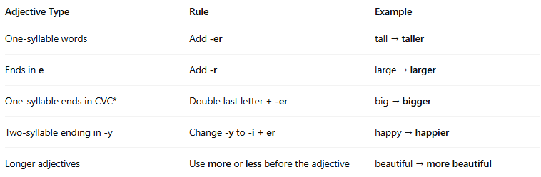
Adjective Type | Rule | Example
One-syllable words | Add -er | tall → taller
Ends in e | Add -r | large → larger
One-syllable ends in CVC* | Double last letter + -er | big → bigger
Two-syllable ending in -y | Change -y to -i + er | happy → happier
Longer adjectives | Use more or less before the adjective | beautiful → more beautiful
CVC = consonant–vowel–consonant (e.g., b-i-g)

📚 Examples in Sentences
# Source: AI Source: Provided by: [Data Path: Persons Table -> ID Column: 1, Name_En Column: Motasem Essam] -> From: [Chatgpt (GPT-4-turbo)] on [7/27/2025]
- This book is shorter than that one.
- She is more intelligent than her brother.
- My house is bigger than yours.
- This exam was less difficult than the last one.

❗Important Notes
# Source: AI Source: Provided by: [Data Path: Persons Table -> ID Column: 1, Name_En Column: Motasem Essam] -> From: [Chatgpt (GPT-4-turbo)] on [7/27/2025]
- Only two things are being compared.
- Don’t use more with adjectives that already end in -er.
❌ more taller → ✅ taller

🧠 Common Comparative Adjectives (Irregular)
# Source: AI Source: Provided by: [Data Path: Persons Table -> ID Column: 1, Name_En Column: Motasem Essam] -> From: [Chatgpt (GPT-4-turbo)] on [7/27/2025]
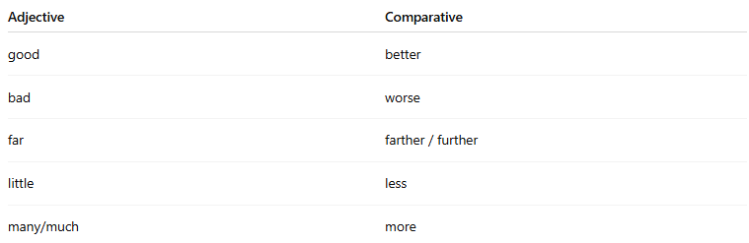
Adjective | Comparative
good | better
bad | worse
far | farther / further
little | less
many/much | more

